**CIRCLE GEOMETRY**

**Extended investigation Part 1:** **Preparation activity**

**Using the Geometry Application on the TI CAS**

|  |  |
| --- | --- |
| **1.** | **[Marks]** |
|  | Write a definition for each of following. |
| **Central Angle:** |  |
| **Chord:** |  |
| **Cyclic quadrilateral:** |  |
| **Diameter:** |  |
| **Radius:** |  |
| **Major/Minor Arc:** |  |
| **Major/Minor Segment:** |  |
| **Alternate Segment:** |  |
| **Major/Minor Sector:** |  |
| **Secant:** |  |
| **Semicircle:** |  |
| **Tangent:** |  |

|  |  |
| --- | --- |
| **2.** | **[ Marks]** |
| a) | Why do you think ∠BED is referred to as the angle in the semicircle? |
|  |  |
| b) | What do you notice about the size of ∠BED as point E moves around the circle? |
|  |  |
| c) | Make a conjecture about the size of the angle in a semicircle. |
|  |  |
| d) | **Conjecture:** The angle in a semicircle is … |

|  |  |
| --- | --- |
| **3.** | **[ Marks]** |
|  | A proof of your conjecture about the angle in a semicircle has been started for you. Complete the proof. Remember that statements in the proof need to be justified. |
|  | **Angle in a Semicircle Theorem** |
|  | **Given**: Circle centre A, diameter BD. E is any point on the circle, ∠BED is an angle in the semicircle DBE.  **To Prove**:  **Extension to**  **the diagram:** Draw AE.  **Proof:**   |  |  | | --- | --- | | **Statement** | **Reason(Justification)** | |  |  | |

|  |  |
| --- | --- |
| **4.** | **[ Marks]** |
| a) | By which arc are angles CBD and CAD both subtended? |
|  |  |
| b) | What do you notice about the size of the angle subtended at the centre of the circle,  ∠CAD, and the size of the angle subtended at the circumference of the circle, ∠CBD? |
|  |  |
| c) | Make a conjecture about the size of the angle at the centre subtended by an arc of a  circle and the size of the angle at the circumference subtended by the same arc. |
|  |  |
| d) | **Conjecture:** The size of the angle at the centre subtended by an arc of the circle is … |

|  |  |
| --- | --- |
| **5.** | **[Marks]** |
|  | A proof of your conjecture about the central angle has been started for you. Complete the proof. Remember that statements in the proof need to be justified. |
|  | **Central Angle Theorem** |
|  | **Given**: Circle centre A. ∠CAD is the angle subtended by arc CD at the centre and ∠CBD is the angle subtended by arc CD at the circumference  **To Prove**:  **Extension to**  **the diagram**: Join BA and produce it to E.   |  |  | | --- | --- | | **Statement** | **Reason ( Justification)** | |  |  | |

|  |  |
| --- | --- |
| **6.** | **[ Marks]** |
|  | Prove that two angles at the circumference subtended by the same arc are equal, i.e. . |
|  |  |

**Question 7**

Use the Geometry application to draw a circle centre A and radius AB. Mark points C and D on the circle as shown in the diagram below. Draw EC tangential to the circle at C by drawing a line through C. Tap u to display the Measurement Box. Tap on the line, tap on the circle. If **No** is displayed, tap b. EC is now tangential to the circle at C. Draw line segment EC and chords BD, CD and BC. ∠CBD is an angle in the alternate segment to ∠DCE.

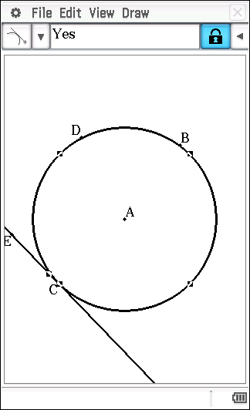 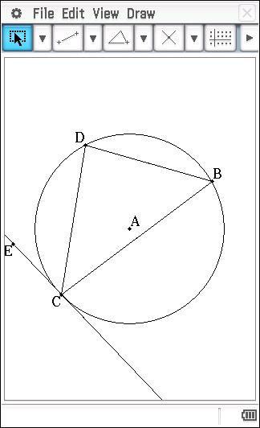

Note: it will be necessary to draw line segment EC prior to measuring the size of ∠DCE.

|  |  |
| --- | --- |
| **7.** | **[Marks]** |
| a) | Whilst maintaining the location of ∠CBD in the alternate segment to ∠DCE, move point D on the circle. What do you notice about the size of ∠CBD and the size of ∠DCE? |
|  |  |
| b) | Make a conjecture about the angles in the alternate segment. |
|  |  |
|  | **Conjecture:** An angle between a chord and a tangent is … |

**Question 8**

Use the Geometry application to draw a circle centre A and radius AB. Position point C anywhere outside the circle and point D on the circle. Draw line segments CB and CD. Tap u to display the Measurement Box. Tap on CB, tap on the circle. If **No** is displayed, tap the tick, b. CB is now a tangent to the circle at B. In a similar manner, make CD a tangent to the circle at D.

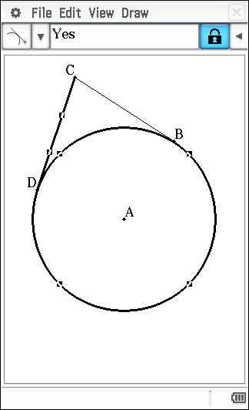

|  |  |
| --- | --- |
| **8** | **[Marks]** |
| **a)** | What do you notice about the lengths of tangents CB and CD as you change the location of  point C? |
|  |  |
| **b)** | Make a conjecture about the lengths of the tangents drawn from a point to a circle. |

**Question 9**

Use the Geometry application to draw a circle centre A and radius AB**.** Use y to draw intersecting chords BC and DE. Select BC and DE, tap 7 to determine F, the point of intersection of chords BC and DE. Tap u to display the Measurement Box.

Display the length of chord BF by tapping on B and on F. Tap on the size of BF and drag it into the Geometry window. Label this chord length BF.

In a similar manner, display the length of chords CF, DF and EF.

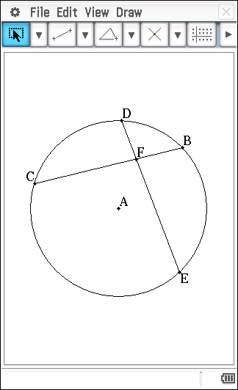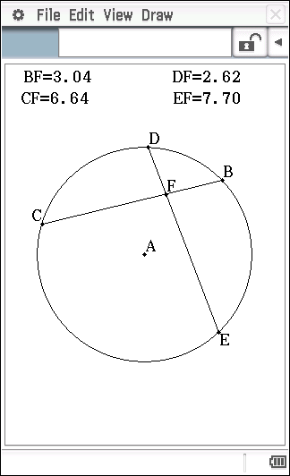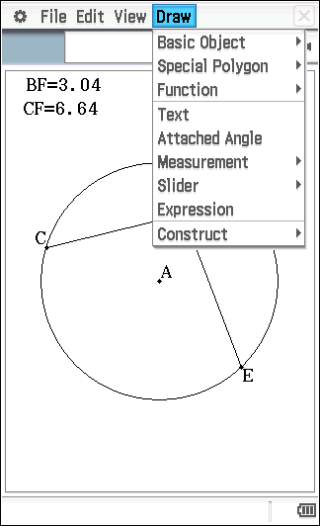

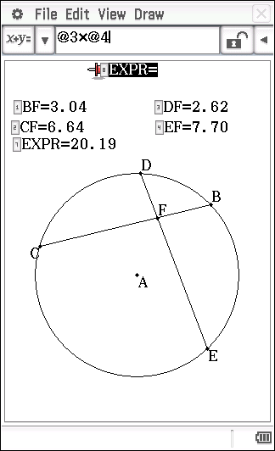

To calculate the product of BF and CF, tap Draw, tap Expression. Tap BF, press *, tap CF, press E. In a similar manner, display the product of DF and EF.

|  |  |
| --- | --- |
| **9.** | **[Marks]** |
| **a)** | What do you notice about BF x CF and DF x EF as you change the locations of C, D, E and  F? |
|  |  |
| **b)** | Make a conjecture about the product of the lengths of the intervals on one chord and the product of the lengths of the intervals of an intersecting chord. |
|  |  |

|  |  |
| --- | --- |
| **10** | **[Marks]** |
| **a)** | AB, AC and BC are tangents; AB = 15 cm; BC = 17 cm; BP = 9 cm. Find AC. |
| **b)** | AB and AC are tangents; . Find the size of |
| **c)** | PE is a tangent; AD is parallel to PC; . Find the size  and . |

**CIRCLE GEOMETRY**

**Extended investigation Part 1:** **Preparation activity**

**Solutions**

**Question 1**

|  |
| --- |
| **Central Angle:** An angle whose vertex is at the centre and whose sides are radii.  **Chord:** An interval joining two points on the circle.  **Cyclic quadrilateral:** A cyclic quadrilateral is a quadrilateral whose vertices all lie on a circle.  **Diameter:** A chord that passes through the centre.  **Radius:** Any line segment joining a point on the circle to the centre.  **Major/Minor Arc:** A part of the circumference of the circle. A major arc represents more than half of the circumference; a minor arc represents less than half of the circumference.  **Major/Minor Segment:** The part of the circular region enclosed between a chord (not a diameter) and the circle. A major segment encloses a region greater than that of the semicircle; a minor segment encloses a region smaller than that of the semicircle.  **Alternate Segment:** The word ‘alternate’ means ‘other’. The chord *AB* divides the circle into two segments and *AU* is tangent to the circle. Angle *APB* ‘lies in’ the segment on the other side of chord *AB* from angle *BAU.* We say that it is in the alternate segment.    **Major/Minor Sector:** The portion of a circular region bounded by two radii and an arc. A major sector covers a region greater than that of the semicircle; a minor sector covers a region smaller than that of the semicircle.  **Secant:** A line that cuts a circle at two distinct points.  **Semicircle:** Half a circular region, formed by the diameter and half the circle.  **Tangent:** A line that intersects a circle at one point. |

**Question 2**

|  |
| --- |
| (a) The angle formed by the diameter and two chords lies in a semicircle.  (b) The size of the angle remains unchanged.  (c) The angle in a semicircle is a right angle. |

**Question 3**

|  |
| --- |
| **Angle in a Semicircle Theorem**    **Given**: Circle centre A, diameter BD. E is any point on the circle, ∠BED is an angle in the semicircle DBE.  **To Prove**: ∠BED = 90°  **Extension to**  **the diagram:** Draw AE.  **Proof:** |

**Question 4**

|  |
| --- |
| (a) arc CD  (b) ∠CAD = 2 x ∠CBD  (c) The size of the angle at the centre subtended by an arc of the circle is twice the size of the angle at the circumference subtended by the same arc. |

**Question 5**

|  |
| --- |
| **Central Angle Theorem**    **Given**: Circle centre A. ∠CAD is the angle subtended by arc CD at the centre and ∠CBD is the angle subtended by arc CD at the circumference  **To Prove**:  **Extension to**  **the diagram**: Join BA and produce it to E.  **Proof:** |

**Question 6**

|  |
| --- |
| **Given**: Circle centre O. ∠APB and ∠AQB are angles at the circumference subtended by arc AB.  **To Prove**:  **Proof:** |

**Question 7**

|  |
| --- |
| (a) The two angles are the same size.  (b) An angle between a chord and a tangent is equal to any angle in the alternate segment. |

**Question 8**

|  |
| --- |
| (a) The tangents from C to the circle are equal in length.  (b) Tangents drawn to a circle from an external point are equal in length. |

**Question 9**

|  |
| --- |
| (a) The products are the same.  (b) When two chords of a circle intersect, the product of the lengths of the intervals on one chord equals the product of the lengths of the intervals on the other chord. |

**Question 10 (a)**

|  |
| --- |
|  |

**Question 10 (b)**

|  |
| --- |
|  |

**Question 10 (c)**

|  |
| --- |
|  |

**Name: ………………………….**

**CIRCLE GEOMETRY**

**Extended investigation Part 2:** **In-class validation**

**Question 1 (6 marks)**

Write a description of the theorem next to the diagram.

(a) Angle in a Semicircle (1)

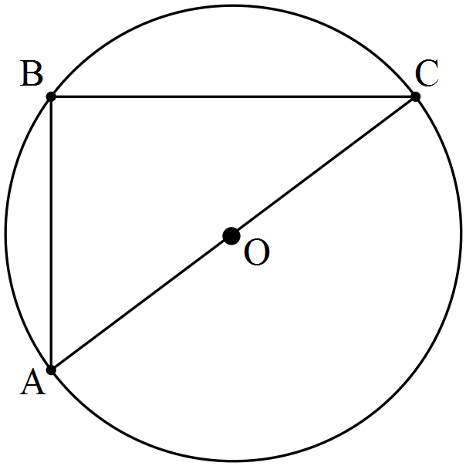

(b) Central Angle Theorem (1)

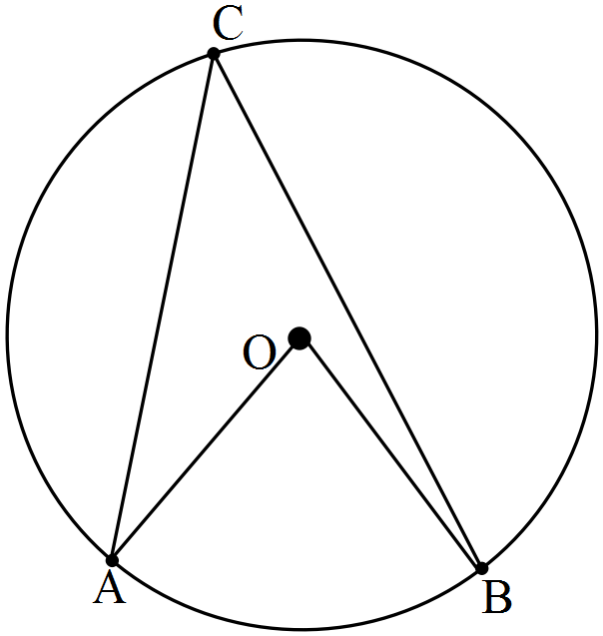

(c) Angle in the Alternate Segment Theorem (1)

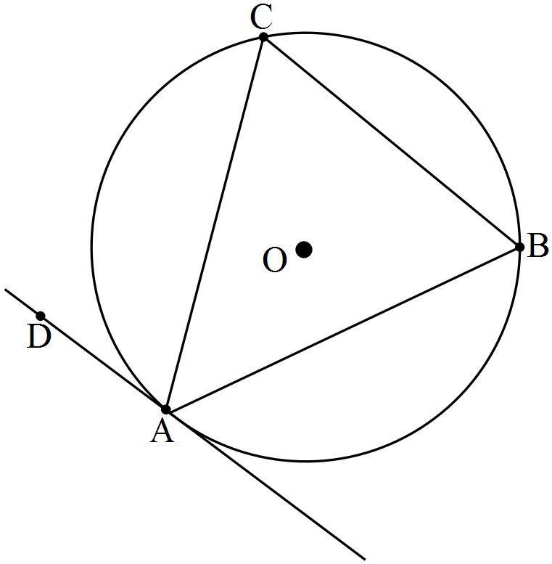

(d) Length of Tangents Theorem (1)

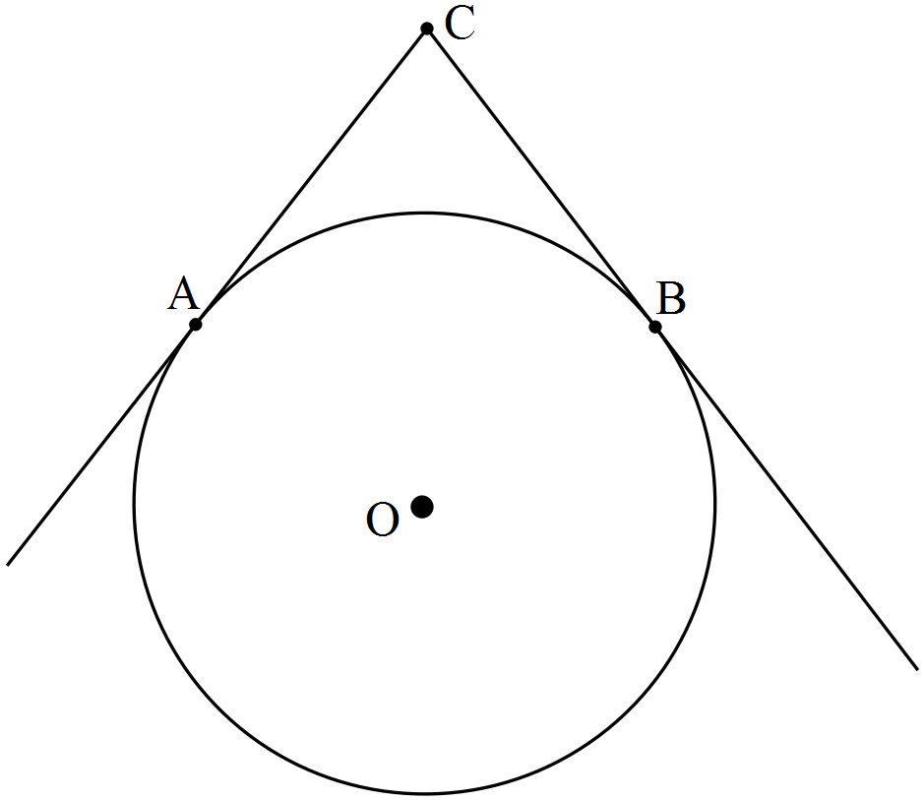

(e) Intersecting Chords Theorem (1)

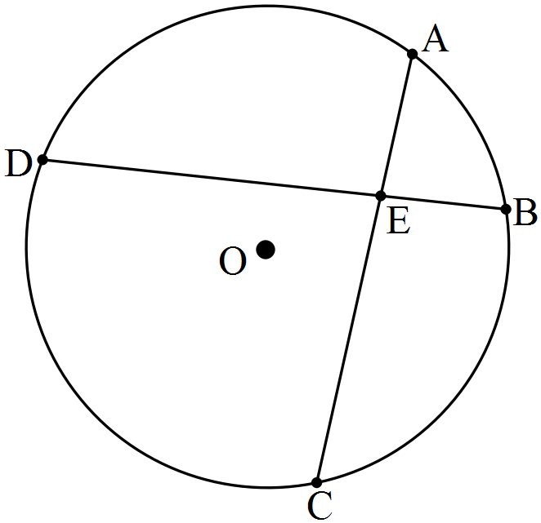

(f) Angles at the circumference of a circle subtended by the same arc. (1)

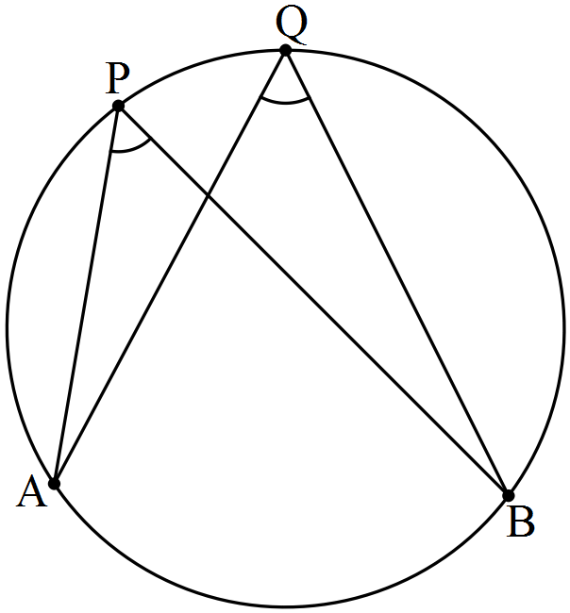

**Question 2 (5 marks)**

Complete the following proof.

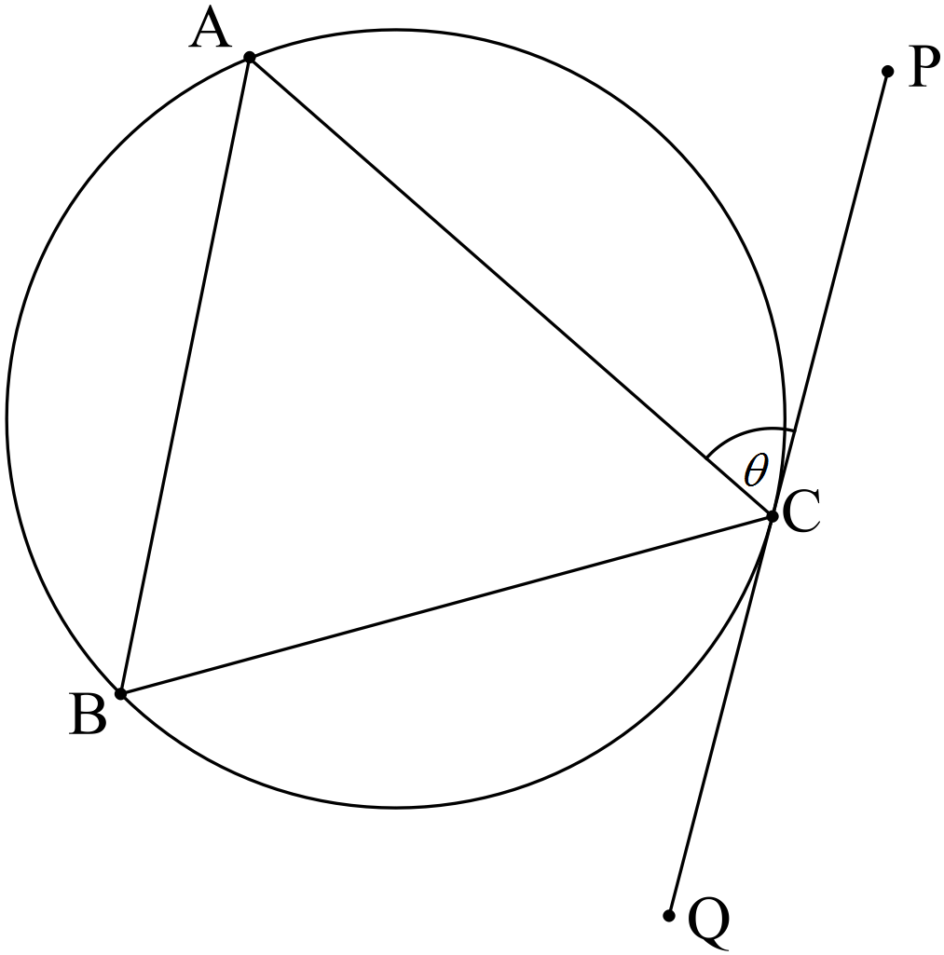

Given: PQ is tangential to the circle at C, CA = CB, .

To Prove: PQ is parallel to AB.

Proof:

**Question 3 (5 marks)**

Complete the following proof.

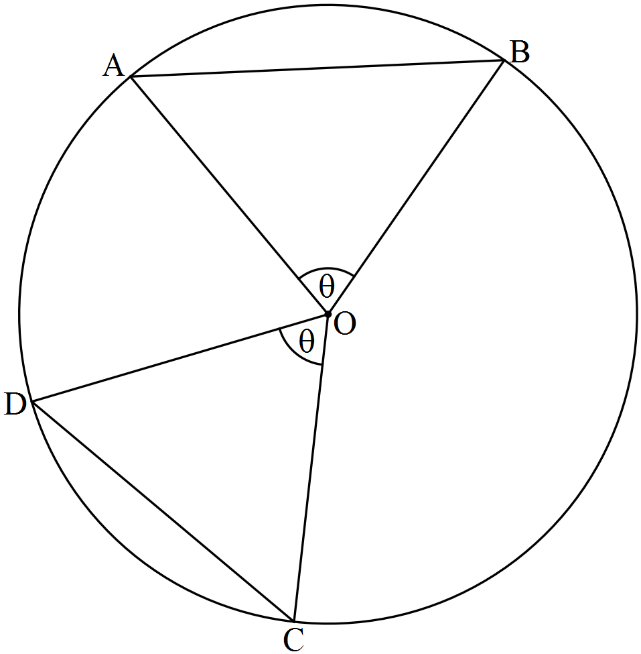

Given: Circle centre O with chords AB and CD, .

To Prove: Chords AB and CD are equal in length.

Proof:

**Question 4 (4 marks)**

Complete the following proof.

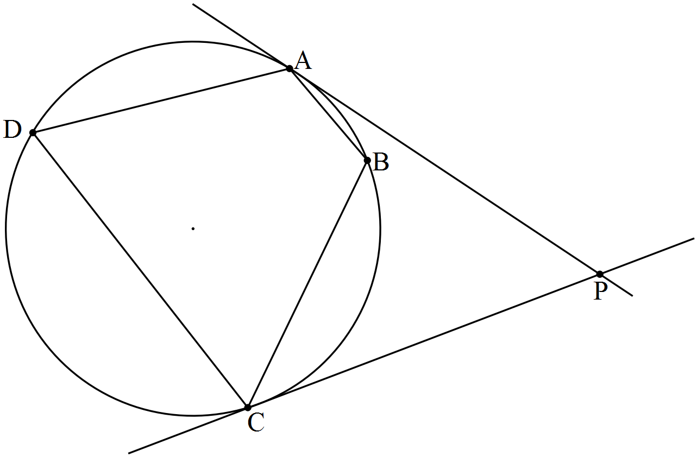

Given: A, B, C and D are four points on a circle such that ABC form a minor arc of the circle. The tangents at A and C meet at P.

To Prove: 

**Question 5 (6 marks)**

Complete the following proof.

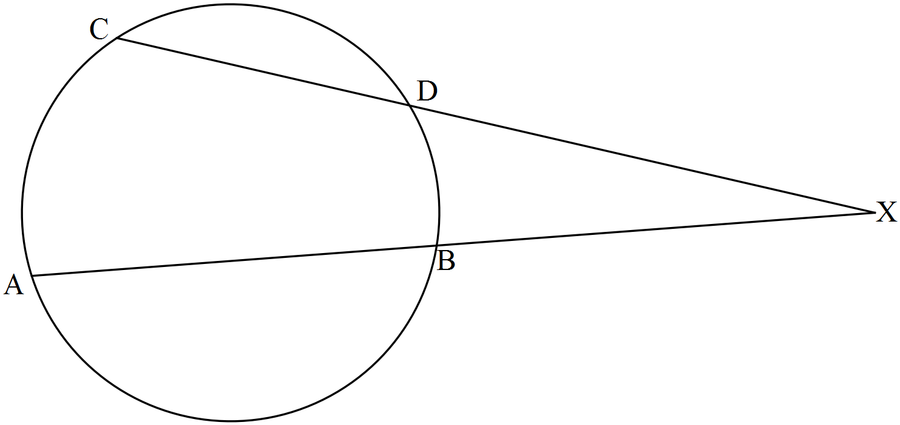

Given: Circle centre O with chords AB and CD intersecting externally at X.

To Prove: XA.XB = XC.XD

**Question 6 (5 marks)**

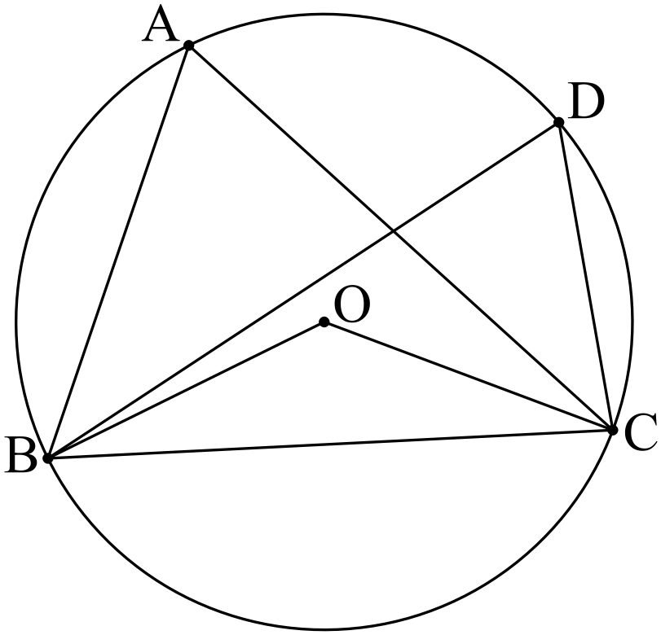

Given  and , determine the size of 

**Question 7 (6 marks)**

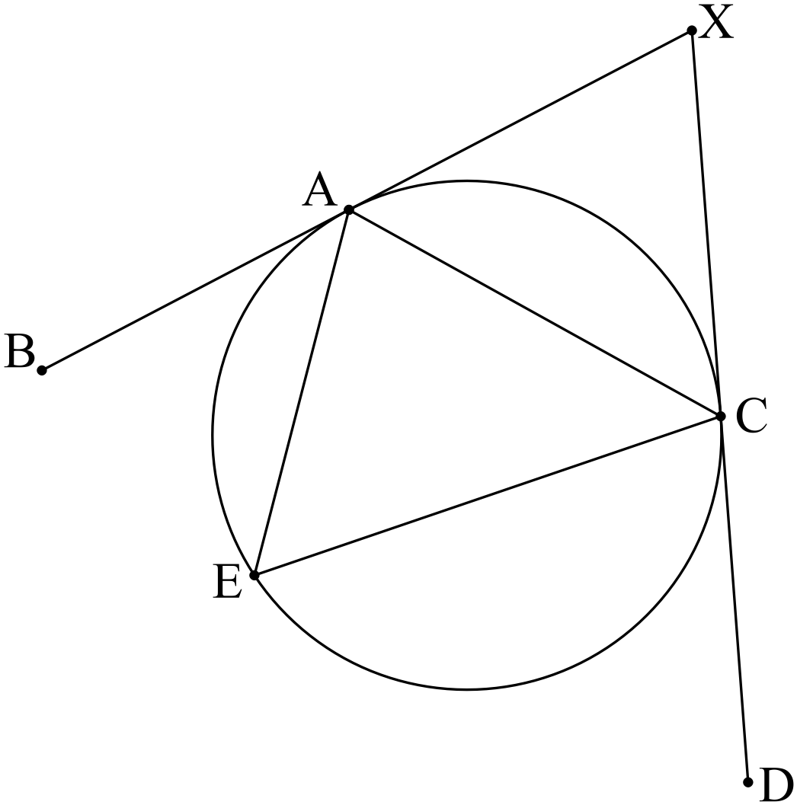

Given XB and XD are tangents,  and , determine the size of 

**CIRCLE GEOMETRY**

**Extended investigation Part 2:** **In-class validation**

**Solutions and marking key**

**Question 1 (a)**

|  |  |
| --- | --- |
| Angle in a Semicircle: An angle in a semicircle is a right angle. | |
| Marking key/mathematical behaviours | Marks |
| * Correct description | 1 |

**Question 1 (b)**

|  |  |
| --- | --- |
| Central Angle Theorem: The size of the angle at the centre subtended by an arc of the circle is twice the size of the angle at the circumference subtended by the same arc. | |
| Marking key/mathematical behaviours | Marks |
| * Correct description | 1 |

**Question 1 (c)**

|  |  |
| --- | --- |
| Angle in the Alternate Segment Theorem: An angle between a chord and a tangent is equal to any angle in the alternate segment. | |
| Marking key/mathematical behaviours | Marks |
| * Correct description | 1 |

**Question 1 (d)**

|  |  |
| --- | --- |
| Length of Tangents Theorem: Tangents drawn to a circle from an external point are equal in length. | |
| Marking key/mathematical behaviours | Marks |
| * Correct description | 1 |

**Question 1 (e)**

|  |  |
| --- | --- |
| Intersecting Chords Theorem: When two chords of a circle intersect, the product of the lengths of the intervals on one chord equals the product of the lengths of the intervals on the other chord. | |
| Marking key/mathematical behaviours | Marks |
| * Correct description | 1 |

**Question 1 (f)**

|  |  |
| --- | --- |
| Angles at the circumference of a circle subtended by the same arc are equal. | |
| Marking key/mathematical behaviours | Marks |
| * Correct description | 1 |

**Question 2**

|  |  |
| --- | --- |
| Given: PQ is tangential to the circle at C, CA = CB, .  To Prove: PQ is parallel to AB.  Proof: | |
| Marking key/mathematical behaviours | Marks |
| * Establishes  is isosceles * Uses property of isosceles triangle to establish congruent angles * Applies angle in alternate segment theorem * Concludes alternate angles are congruent * Concludes PQ is parallel to AB | 1  1  1  1  1 |

**Question 3**

|  |  |
| --- | --- |
| Given: Circle centre O with chords AB and CD, .  To Prove: Chords AB and CD are equal in length.  Proof: | |
| Marking key/mathematical behaviours | Marks |
| * Establishes two pair of sides are congruent * Gives reason, radii * Establishes * Gives reason * Concludes chords equal in length | 1  1  1  1  1 |

**Question 4**

|  |  |
| --- | --- |
| Given: A, B, C and D are four points on a circle such that ABC form a minor arc of the circle. The tangents at A and C meet at P.  To Prove:  Extension to  the diagram: Draw chord BD  Proof: | |
| Marking key/mathematical behaviours | Marks |
| * Draws chord BD * Applies angle in alternate segment theorem to * Applies angle in alternate segment theorem to * Establishes | 1  1  1  1 |

**Question 5**

|  |  |
| --- | --- |
| Given: Circle centre O with chords AB and CD intersecting externally at X.  To Prove: XA.XB = XC.XD  Extension to  the diagram: Draw chords AD and BC  Proof: | |
| Marking key/mathematical behaviours | Marks |
| * Draws chords AD and BC * Establishes * Establishes * States reason for similar triangles * Equates ratios of corresponding sides * Establishes product | 1  1  1  1  1  1 |

**Question 6**

|  |  |
| --- | --- |
|  | |
| Marking key/mathematical behaviours | Marks |
| * Establishes size of * Applies central angle theorem to determine size of * Establishes is isosceles * Establishes size of * Establishes size of | 1  1  1  1  1 |

**Question 7**

|  |  |
| --- | --- |
|  | |
| Marking key/mathematical behaviours | Marks |
| * Applies angle in alternate segment theorem to establish size * Applies angle in alternate segment theorem to establish size * Applies length of tangents theorem to establish * Concludes * Determines size of * Uses straight angle to determine size of | 1  1  1  1  1  1 |